COMPLETE TENNIS
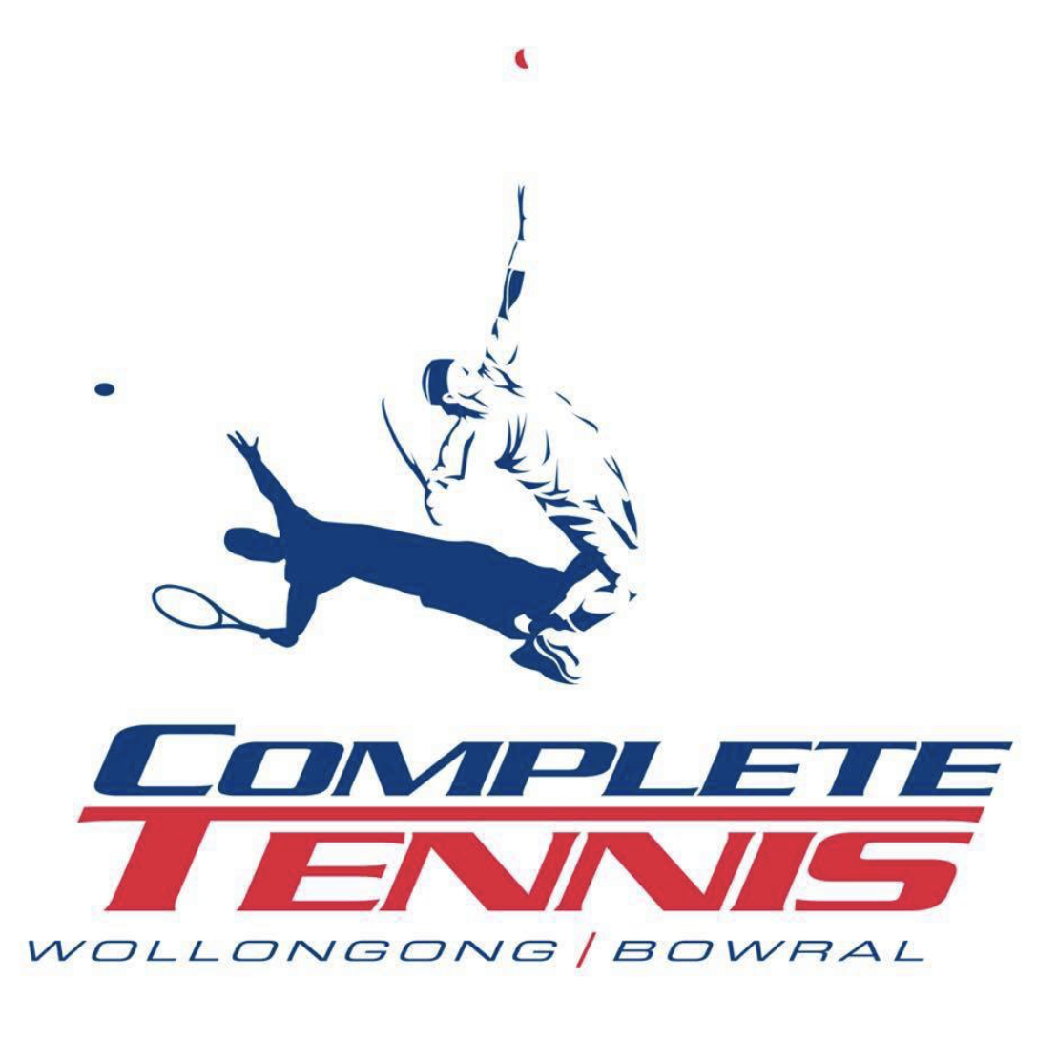

Child Safe
Policy

Instructions
A Child Safe Policy is a key child safe document that outlines how your organisation puts in place the Child Safe Standards in its everyday practices.
This sample template provides basic content to get you started. Follow these steps to develop your own Child Safe Policy. For more information on how to develop your organisation’s Child Safe Policy, download the OCG’s Understanding and Developing a Child Safe Policy handbook.
- Adapt the content provided in the sample to suit your organisation as it relates to your activities, staffing and structure.
- Read the Notes in the purple boxes for extra guidance.
- Ask people across your organisation to review and provide feedback.
- Delete the Notes boxes and these instructions when finished.
- Add your organisation’s name and branding.
- Share this policy across your organisation and make sure it is easily available on your website and offline for everyone who accesses your services and events, including children, parents, carers and families.

Purpose
All children at Complete Tennis have a right to feel safe, protected and included.

This policy is part of our organisation’s ongoing commitment to protecting the children in our care from harm and abuse. It:
- outlines the child safe practices our organisation has put in place to minimise the risks to child safety
- sets out what is required from staff, including volunteers and others who interact with our organisation, so they know what is expected from them to keep children safe.

Our commitment to child safety
At Complete Tennis we commit to the safety and wellbeing of every child in our care. Please read our Statement of Commitment to Child Safety, which is available on our website http://www.bowraltennis.com.au/CT-Home.aspx and is displayed http://www.bowraltennis.com.au/CT-OCG-childsafe.aspx.
Our organisation ensures services and activities are inclusive of all children, including children with diverse needs.

Scope and audience for this policy
The policy describes what is required from all staff, ie, the coaches in the organisation when taking part in any activities, services and events that involve children.

Responsibilities for children’s safety
Everyone in our organisation is expected to carry out the requirements specific to their role to keep children safe. This includes:
- upholding our organisation’s commitment to child safety
- reading, signing and upholding the behaviours set out in our Child Safe Code of Conduct
- meeting requirements across all other child safe policies and procedures, including child safe recruitment practices and risk management
- taking part in our regular reviews of our child safe documents
- reporting all breaches of our policies or any allegations of child harm or abuse, and meeting all external reporting obligations
- completing all child safe training.
Please contact Tristan Whitehill OR Susie Purvis with any of your child-safety related questions or concerns.

Active participation of children, families and communities

- All our child-related policies and procedures are easily accessible on our website and offline for everyone who accesses our services and events, including children, parents, carers and community members.
- Children, parents and carers from diverse backgrounds and circumstances are encouraged to provide feedback on our child-related policies and procedures, including our Child Safe Code of Conduct that describes acceptable and non-acceptable behaviours and our Child Safe Risk Management Plan.
- We provide opportunities for children to provide feedback to our management, board or committee on what makes them feel safe, supported and included.

Definitions of harm and abuse

General definitions
Psychological abuse (also known as emotional abuse)
This includes bullying, threatening and abusive language, intimidation, shaming and name calling, ignoring and isolating a child, and exposure to domestic and family violence.
Physical abuse
This includes physical punishment, such as pushing, shoving, punching, slapping and kicking, resulting in injury, burns, choking or bruising.
Sexual abuse
This includes the sexual touching of a child, grooming, and production, distribution or possession of child abuse material.
Grooming
This is a process where a person manipulates a child or group of children and sometimes those looking after them, including parents, carers, teachers and leaders. They do this to establish a position of ‘trust’ so they can then later sexually abuse the child.
Misconduct
This is inappropriate behaviour that may not be as severe as abuse, but could indicate that abuse is occurring and would often be in breach of an organisation’s Child Safe Code of Conduct. This could include showing a child something inappropriate on a phone, having inappropriate conversations with a child or an adult sitting with a child on their lap.
Lack of appropriate care
This includes not providing adequate and proper supervision, nourishment, clothing, shelter, education or medical care.

What the policy covers

Transporting children
Sometimes children need to be transported to tournaments by Complete Tennis’s head coaches. This is an arrangement organised by the parents themselves. Best practice is to always have two adults travelling with children. Of course this is not always possible so an arrangement will organised by the parents and Tristan or Susie. If a child is alone with an adult in a car they must sit on the back seat. Every child should be accounted for at the end of a journey.

Social media use and online communication
Staff and volunteers must never communicate privately with children online or on social media. Any necessary online communication should include the child’s parent or carer in the correspondence.

Photography and the use of images
Photos and videos of children can only be taken with the permission of parents or carers. Parents and carers must also approve any images used on our social media channels. It is unacceptable for staff or volunteers to take photos or videos of children, other than their own, on personal devices, or to share images without permission.

Physical contact
Physical contact with children must always be appropriate, necessary, and in line with the aims of tennis coaching. All coaches, staff and other parents involved with Complete Tennis are expected to maintain healthy and professional physical boundaries with children at all times.
- Physical contact should be kept to a minimum and only occur when essential for safety or instructional purposes (eg to demonstrate grip or positioning).
- Whenever possible, coaching should be delivered through verbal instructions and visual demonstrations, rather than physical correction.
- If physical contact is required, it should be:
- Brief and clearly explained to the child beforehand
- Proportionate and appropriate to the situation
- Conducted in an open environment in view of others
- Immediately stopped if the child expresses discomfort or resistance
Coaches must never engage in physical contact that could be seen as inappropriate, intimate, or unwelcomed and must avoid physical behaviour that could be misinterpreted. By maintaining clear physical boundaries, we promote a safe and respectful environment where children can learn and enjoy tennis with confidence.

Gifts and benefits
Staff and volunteers must never give gifts to children, or bestow benefits of any kind to a child, unless they have direct permission from the child’s parents or carers.

Secondary employment
Staff and volunteers are not allowed to babysit children in our care unless they know the family or carer outside the organisation. It this is the case, they must let the organisation know that this arrangement is in place so it can be documented.

Out of hours contact with children
Staff and volunteers must let us know about any out-of-hours contact they have with children in our care. It is unacceptable for staff or volunteers to participate in the lives of children outside the organisation without a valid reason. Professional boundaries with the children in our care must be maintained at all times.

Illness and injury management
Injuries must be reported to the first aid officer on duty and first aid administered in a safe space within lines of sight of other adults.

Reporting requirements for different types of concerns or incidents

Child Safe Reporting Policy
Our Child Safe Reporting Policy sets out requirements and procedures for complaints, allegations, disclosures and reports, and external reporting obligations. It can be accessed at http://www.bowraltennis.com.au/CT-Home.aspx.

Other related child safe documents

Complete Tennis has a range of other key documents that relate to child safety. These can be accessed at http://www.bowraltennis.com.au/CT-Home.aspx, and include:

Statement of Commitment to Child Safety
Our public commitment to prioritising child safety across our organisation.

Child Safe Code of Conduct
Code of Conduct for Adults Interacting with Children
At our tennis club, we are committed to providing a safe, respectful, and positive environment for all children. Adults—including coaches, staff, volunteers, and parents—are expected to:
1. Prioritize Safety: Ensure children are supervised at all times and respond promptly to any concerns or incidents.
2. Model Respect: Treat children with kindness, patience, and respect. Avoid yelling, sarcasm, or belittling behaviour.
3. Use Appropriate Boundaries: Maintain professional and appropriate physical and emotional boundaries at all times.
4. Encourage Positive Development: Focus on effort, learning, and enjoyment rather than just winning. Offer constructive feedback and celebrate improvement.
5. Promote Inclusion: Support an environment free of discrimination, bullying, or exclusion. Welcome children of all backgrounds and abilities.
6. Report Concerns: Speak up if you witness inappropriate behaviour or have concerns about a child’s wellbeing.
By following these principles, we create a safe and enjoyable environment that allows every child to thrive through the sport of tennis.

Child Safe Recruitment, Induction and Training Policy
Sets out what is involved in the recruitment process and the procedures to be followed before a person is considered for a role at the organisation. This includes the verification of their Working with Children Check. It also outlines what is involved in the induction process for new recruits and any further training requirements.

Child Safe Risk Management Plan
Describes the specific risks at the service that could affect children's safety and identifies the protective strategies used to lower each risk.

Publication, communication and engagement
Website
Emails
Notice boards
Training

Our Child Safe Policy and other child safe documents can be found on our website at http://www.bowraltennis.com.au/CT-Home.aspx. Anyone involved in our community can request a copy via email at any time. We send out regular email reminders to our community about our child safe documents and invite feedback whenever one of our organisation’s child safe documents is up for review.

Related legislation, regulations and standards

Complete Tennis has to understand and comply with a number of NSW child protection laws and schemes. These include:
- NSW Child Safe Scheme
- Children’s Guardian Act 2019
- Child Protection (Working with Children) Act 2012
- Child Protection (Working with Children) Regulation 2013
- Children and Young Persons (Care and Protection) Act 1998

Next review date
1/07/2025, or earlier if there are any critical incidents

This sample template was developed by the NSW Office of the Children’s Guardian.

For more free child safe resources, visit ocg.nsw.gov.au/our-resources.

